**Department of Industrial and Systems Engineering**

**Indian Institute of Technology, Kharagpur**

**Simulation Lab**

**Time-2:00 pm to 5:00 pm Date: 12/02/2021**

**__________________________________________________________________**

**Demonstration problem**

The emergency room of a small hospital operates around the clock. It is staffed by three receptionists at the reception office, and two doctors on the premises, assisted bytwo nurses. Following figure depicts a diagram of patient sojourn (temporary stay) in the emergency roomsystem, from arrival to discharge.

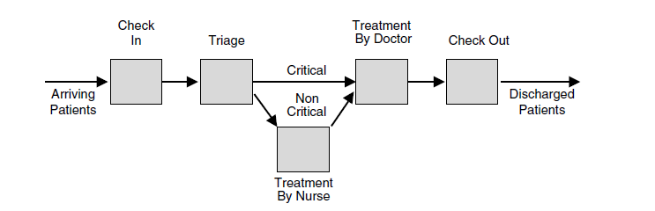

Patients arrive at the emergency room according to a Poisson process with mean Inter-arrival time of 10 minutes. An incoming patient is first checked into the emergency room by a receptionist at the reception office. Check-in time is uniform between 6 and12 minutes. Since critically ill patients get treatment priority over noncritical ones, each patient first undergoes triage in the sense that a doctor determines the criticality level of the incoming patient in FIFO order. The triage time distribution is triangular with a minimum of 3 minutes, a maximum of 15 minutes, and a most likely value of 5minutes. It has been observed that 40% of incoming patients arrive in critical condition, and such patients proceed directly to an adjacent treatment room, where they wait FIFO to be treated by a doctor. The treatment time of critical patients is uniform between 20 and 30 minutes. In contrast, patients deemed noncritical first wait to be called by a nurse who walks them to a treatment room some distance away. The time spent to reach the treatment room is uniform between 1 and 3 minutes and the treatment time by a nurse is uniform between 3 and 10 minutes. Once treated by a nurse, a noncritical patient waits FIFO for a doctor to approve the treatment, which takes a uniform time between 5 to 10 minutes. Recall that the queuing discipline of all patients awaiting doctor treatment is FIFO within their priority classes, that is, all patients wait FIFO for an available doctor, but critical patients are given priority over noncritical ones. Following treatment by a doctor, all patients are checked out FIFO at the reception office, which takes a uniform time between 10 and 20 minutes, following which the patients leave the emergency room.

***The performance metrics of interest in this problem are as follows:***

* Utilization of the emergency room staff by type (doctors, nurses, and

receptionists)

* Distribution of the number of doctors present in the emergency room
* Average waiting time of incoming patients for triage
* Average patient sojourn time in the emergency room
* Average daily throughput (patients treated per day) of the emergency room

To estimate the requisite statistics, the hospital emergency room needs to simulated for a

period of 2 days (Number of replications 5).

**Practice Problems:**

1. Consider a generic packaging line for some product, such as a pharmaceutical plant producing a packaged medicinal product, or a food processing plant producing packaged foods or beverages. The line consists of workstations that perform the processes of filling, capping, labeling, sealing, and carton packing. Individual product units will be referred to simply as units.

We make the following assumptions:

1. The filling workstation always has material in front of it, so that it never starves.

2. The buffer space between workstations can hold at most five units.

3. A workstation gets blocked if there is no space in the immediate downstream buffer (manufacturing blocking).

4. The processing times for filling, capping, labeling, sealing, and carton packing are

6.5, 5, 8, 5, and 6 seconds, respectively.

Note that these assumptions render our packaging line a push-regime production line. To keep matters simple, no randomness has been introduced into the system, that is, our packaging line is deterministic. It is worthwhile to elaborate and analyze the behavior of the packaging line understudy. The first workstation (filling) drives the system in that it feeds all downstream workstations with units. Clearly, one of the workstations in the line is the slowest (if there are several slowest workstations, we take the first among them). The throughput (output rate) of that workstation then coincides with the throughput of the entire packaging line. Furthermore, workstations upstream of the slowest one will experience excessive buildup of WIP inventory in their buffers. In contrast, workstations downstream of the slowest one will always have lightly occupied or empty WIP inventory buffers. Thus, the slowest workstation acts as a bottleneck in our packaging line. Of Course, this behavior holds for any deterministic push-regime production line. Assume the interarrival is exponential with mean of 10 minutes.

1. Items arrive from an inventory picking system according to an exponential inter arrival time, distribution with mean 1.1 minute. With the first arrival time ‘0’. Upon arrival the item is packed by one of four identical packers with single queue feeding all four packers. The packing time is TRIA (2.75, 3.3, 4.0) (min: 2.75, most likely: 3.3, max 4.0) min. The packed boxes are then separated by types (20% international and 80% domestic) and send to shipping.

There is a single shipper (shipping agent) for international packages and two agents for domestic packages with a single queue feeding the two domestic agents. The international shipping agent time is TRIA (2.3, 3.3, and 4.8) min and domestic shipping agent time is TRIA (1.7, 2.0, and 2.7) min.

The packing system works three 8 hrs. shifts, five days a week. All the packers and shipping agents are given 15 min break 2 hrs. into their shift. Run the simulation for 4 weeks. Consider the first day as warm up period. Run the model 3 replication and find out the throughput, percentage utilization of all resource and the average number in each queue.